**Assignment -1**

1. Start Hadoop single node on Acadgild VM. The command is **start-all.sh**

***Answer 1:***

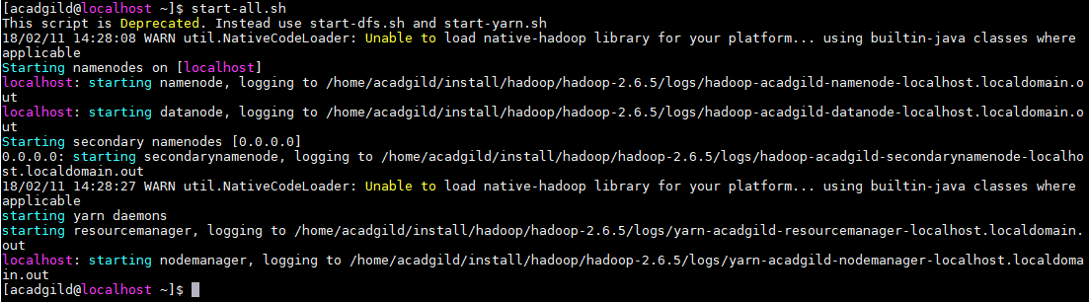

This command is used to start all the daemons in Hadoop.

1. Run JPS command to see if all Hadoop daemons are running.

***Answer 2:***

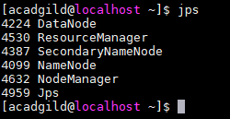

JPScommand is used to check all the Hadoop daemons like NameNode, DataNode, ResourceManager, NodeManager etc. which are running on the machine.

1. Run few unix commands like pwd, ls –ls, etc.

***Answer 3:***

**pwd command:** Gets current working directory.



**ls –ls command:** Lists all the set of directories in the current path.

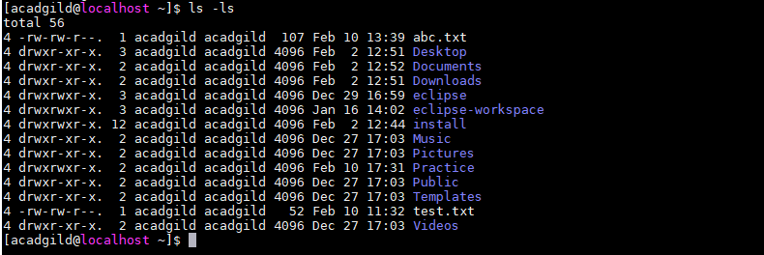

**mkdir command:** To make a new directory.

Refer the yellow highlighted directory in the below screenshot.

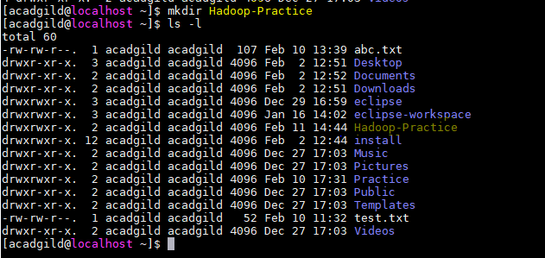

**Cat command:** To see the content of the file.



**Copy command:** To copy the file from one to another file use command “cp <From_file > <To_file>”

Listing is done here to check the new file in the list and again “cat” command is used to see the content.

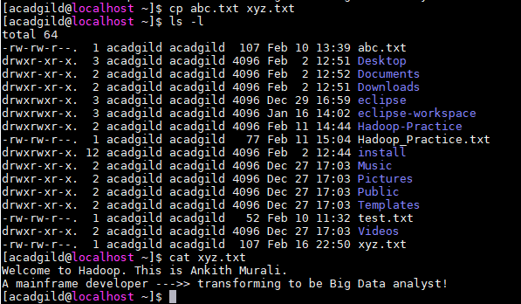

1. Create a file from the terminal using nano editor (example: nano test.txt), add some content in it. Cat it to see if the content is saved.

***Answer 4:***

Use the below command to create file in terminal.



This command will open space to enter the data in Hadoop_Practice.txt file as in below screenshot.

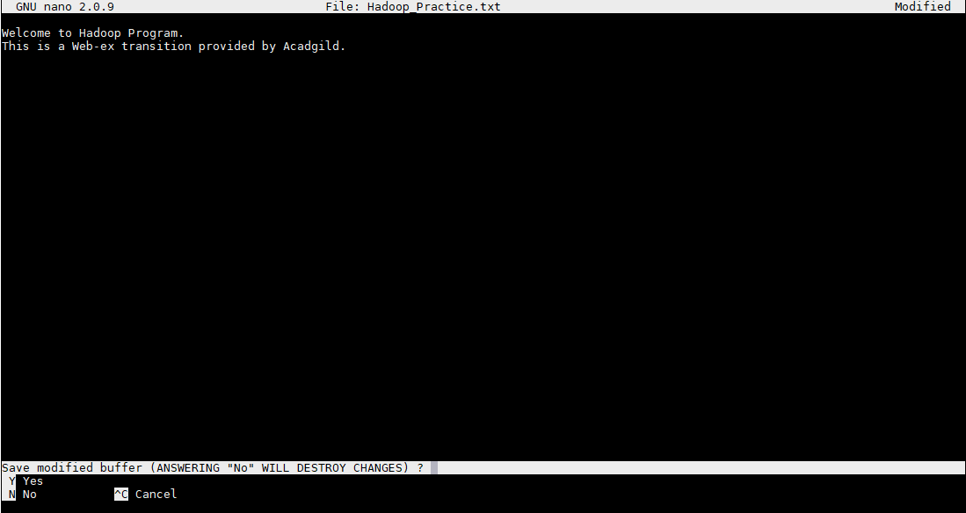

Press Y to save and then press Enter to return to terminal

Use cat command to see the content of file - **Hadoop_Practice.txt** is saved**.**

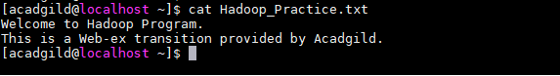

1. Open the hdfs web page by typing *localhost: 50070* in the browser. Check all the details of the HDFS.

**Answer 5:**

The above link opens all the details of HDFS in the web browser only if all the daemons are started in Hadoop.

If the daemons are not started then the web page won’t be opened.

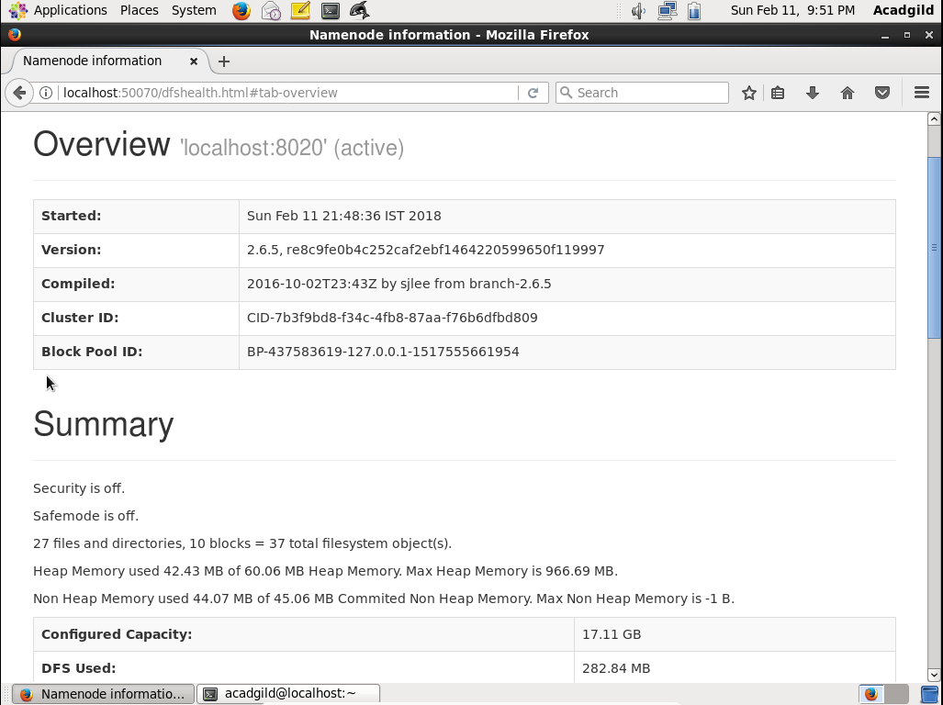

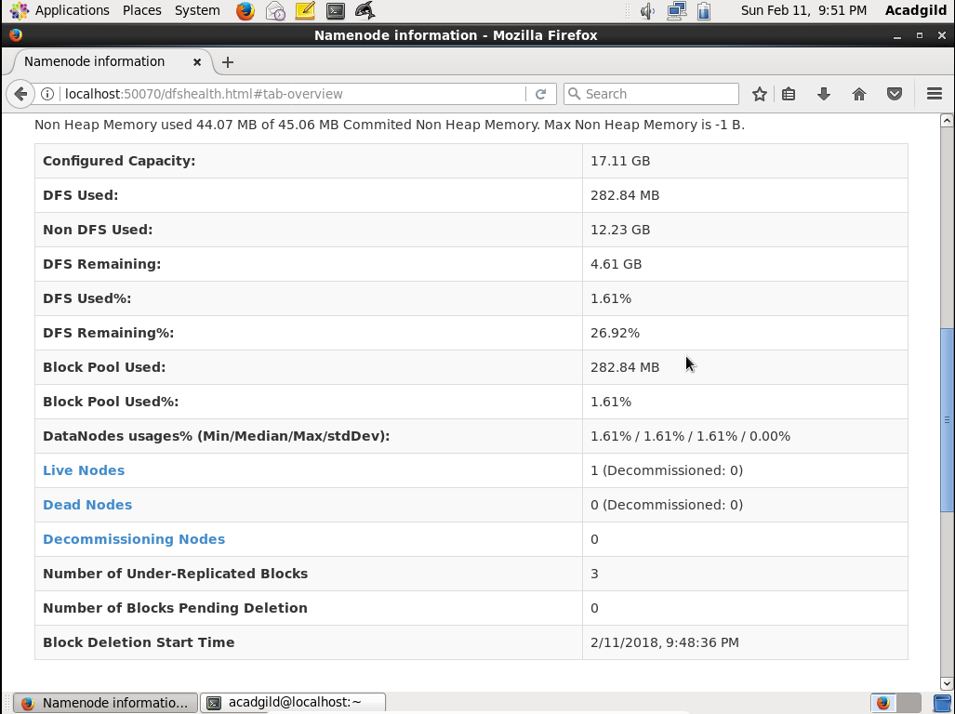

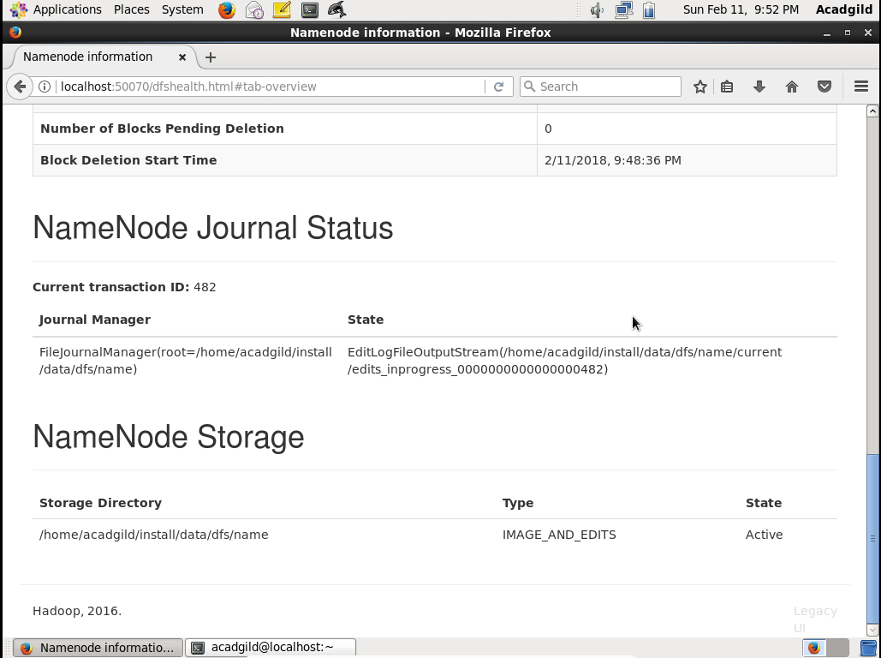

Data Nodes information:

